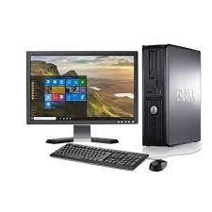

Dell Intel Core 2

* Memory 16 GB
* Optiplex Series
* Speed 2.13 GHz
* Hard Drive Capacity 250 GB
* **Rs.22,352**